MA 322 (2021) Scientific Computing Lab Lab 04

**Name:** Udandarao Sai Sandeep

**Roll Number:** 180123063

**Dept.:** Mathematics and Computing

**Q1.**

Using Mid-point, Trapezoidal and Simpson’s methods, the integral values were estimated. The results are as follows:

For (a) part:

Using Midpoint Method, estimated value of the integral = **0.74048**

Difference between actual and calculated value: **0.117255**

Using Trapezoidal Method, estimated value of the integral = **0.392699**

Difference between actual and calculated value: **0.230526**

Using Simpsons Method, estimated value of the integral = **0.624553**

Difference between actual and calculated value: **0.001328**

For (b) part:

Using Midpoint Method, estimated value of the integral = **0.628319**

Difference between actual and calculated value: **0.418879**

Using Trapezoidal Method, estimated value of the integral = **1.745329**

Difference between actual and calculated value: **0.698131**

Using Simpsons Method, estimated value of the integral = **1.000655**

Difference between actual and calculated value: **0.046543**

For (c) part:

Using Midpoint Method, estimated value of the integral = **0.778801**

Difference between actual and calculated value: **0.031977**

Using Trapezoidal Method, estimated value of the integral = **0.68394**

Difference between actual and calculated value: **0.062884**

Using Simpsons Method, estimated value of the integral = **0.74718**

Difference between actual and calculated value: **0.000356**

**Q2.** Normal methods were followed (Not Composite).

For (a) part:

Using Trapezoidal Method, estimated value of the integral = **7.5**

For (b) part:

Using Simpsons Method, estimated value of the integral = **7.166667**

**Q3.** Since the upper limit is not bounded, the upper limit must be converted to some finite value so that the composite trapezoidal and the composite Simpson’s method can be applied to estimate the integral. The value of x is substituted by $\frac{t}{1-t}$.

The integral now becomes:

$\int_{0}^{1}{\frac{dt}{t^{2}+{9(1-t)}^{2}}}$

The value of **n** has been set to **4**.

The results are as follows:

The estimate using composite trapezoidal method: **0.5098915989159891**

The estimate using composite Simpson’s method: **0.5205962059620596**

The Actual value of the integral: **0.5235987755982988**

**Q4.**

Using the trapezoidal and Simpson’s method, the value of the integral was estimated.

The actual value of the Integral = **1.09861228866811**

The estimate using trapezoidal method: **1.3333333333333333**

The estimate using Simpson’s method: **1.1111111111111112**

Then, the graph of1/(x+2) was plotted in the range [-1,1]. The area under the graph is to be estimated. (depicted by blue shaded region)

Then, the areas calculated for trapezoidal rule and Simpson’s rule was individually plotted out. (orange shaded region). The Trapezoidal plot was made through direct linear estimation, whereas the Simpson’s plot was made through quadratic estimation (using 3 points).

The plots are as follows:

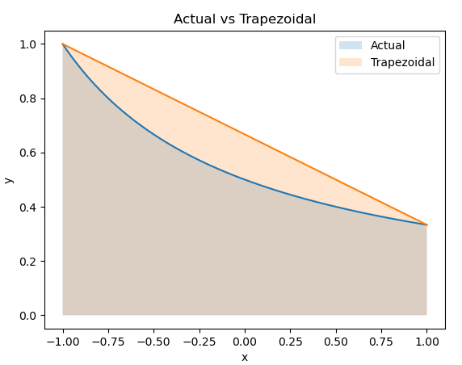

As shown in the figure, **Trapezoidal Estimate is greater than the actual estimate.**

Equation of line: y = -0.33x + 0.66

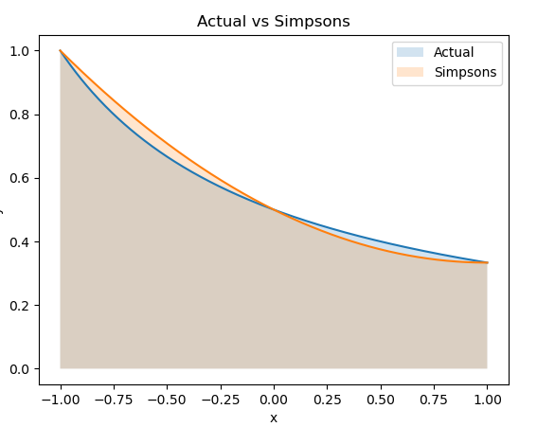

As shown in the figure**, Simpson’s Estimate is almost same as the actual estimate.**

Equation of line: y = 0.1667x*x - 0.33x + 0.5

**Q5.**

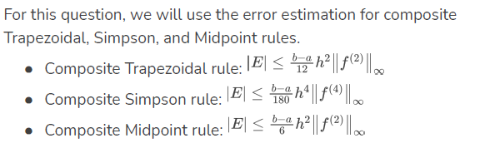

**4th derivative = 24/45, 2nd derivative = 1/32**

Using the above-mentioned error formulas, the results are as follow:

Part (a)

**Constraints: h <= 0.0438178046004133 and n >= 46**

**Required value of n: 46**

**Corresponding value of h: 0.043478260869565216**

The estimate using composite trapezoidal method: **0.4054705778040843**

The difference between actual and calculated value: 5.469695920301554e-06

Part (b)

**Constraints: h <= 0.44267276788012866 and n >= 6**

**Required value of n: 6**

**Corresponding value of h: 0.3333333333333333**

The estimate using composite Simpsons method: **0.4054663745840217**

The difference between actual and calculated value: 1.2664758576863555e-06

Part (c)

**Constraints: h <= 0.03098386676965934 and n >= 65**

**Required value of n: 65**

**Corresponding value of h: 0.03076923076923077**

The estimate using composite midpoint method: **0.40546373841574274**

The difference between actual and calculated value: 1.3696924212602823e-06

**Q6.**

The functional calls were minimized (by avoiding repetitive calls).

Part (a)

Table:

**h T(h/2) Error value**

**1.5000000000 0.9173076923 0.5094339623**

**0.7500000000 1.0970043616 0.1638067045**

**0.3750000000 1.1384585664 0.0364125722**

**0.1875000000 1.1481180340 0.0084133053**

**0.0937500000 1.1505008862 0.0020711433**

**0.0468750000 1.1510947524 0.0005159143**

**0.0234375000 1.1512431055 0.0001288634**

**0.0117187500 1.1512801867 0.0000322087**

**0.0058593750 1.1512894566 0.0000080517**

**0.0029296875 1.1512917740 0.0000020129**

**0.0014648438 1.1512923534 0.0000005032**

**Estimated value: 1.1512923533779342**

**Number of iterations taken: 11**

**Number of function calls: 2049**

Difference between actual and estimated value: 1.9311908872055028e-07

Part (b)

Table:

**h T(h/2) Error value**

**0.4750000000 5.8922619048 0.6928982726**

**0.2375000000 4.0836933187 0.4428757120**

**0.1187500000 3.3570758478 0.2164435669**

**0.0593750000 3.1017719812 0.0823090376**

**0.0296875000 3.0241335026 0.0256729667**

**0.0148437500 3.0029962433 0.0070387232**

**0.0074218750 2.9975598200 0.0018136163**

**0.0037109375 2.9961899090 0.0004572177**

**0.0018554687 2.9958467297 0.0001145517**

**0.0009277344 2.9957608905 0.0000286535**

**0.0004638672 2.9957394280 0.0000071644**

**0.0002319336 2.9957340622 0.0000017912**

**0.0001159668 2.9957327207 0.0000004478**

**Estimated value: 2.9957327207096545**

**Number of iterations taken: 13**

**Number of function calls: 8193**

Difference between actual and estimated value: 4.471556636076457e-07

Part (c)

**For m = 0.5**

**Table:**

**h T(h/2) Error value**

**0.7853981634 1.8549591311 0.0221890424**

**0.3926990817 1.8540752278 0.0004767354**

**0.1963495408 1.8540746773 0.0000002969**

**Estimated value: 1.8540746773016665**

**Number of iterations taken: 3**

**Number of function calls: 9**

**For m = 0.8**

**Table:**

**h T(h/2) Error value**

**0.7853981634 2.2847455921 0.1124222561**

**0.3926990817 2.2576215270 0.0120144430**

**0.1963495408 2.2572054615 0.0001843277**

**0.0981747704 2.2572053268 0.0000000596**

**Estimated value: 2.257205326820873**

**Number of iterations taken: 4**

**Number of function calls: 17**

**For m = 0.95**

**Table:**

**h T(h/2) Error value**

**0.7853981634 3.2328552103 0.3294147895**

**0.3926990817 2.9426673463 0.0986138866**

**0.1963495408 2.9089732769 0.0115828047**

**0.0981747704 2.9083375614 0.0002185838**

**0.0490873852 2.9083372484 0.0000001076**

**Estimated value: 2.9083372484446572**

**Number of iterations taken: 5**

**Number of function calls: 33**

**Q7.**

1. This part is entirely theoretical. The process for finding the error using the inexact function is as follows:

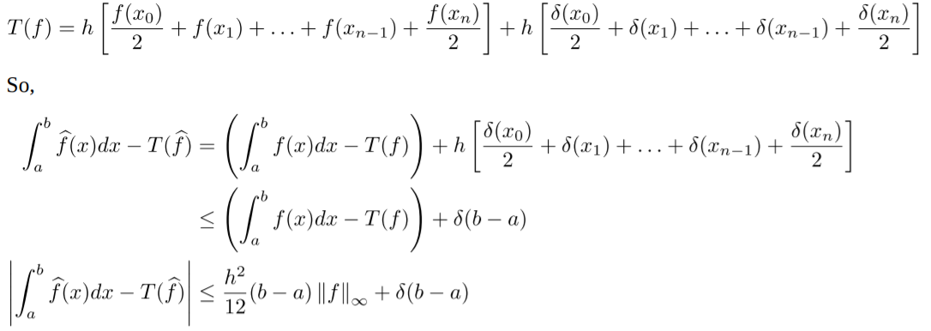

The second term remains fixed irrespective of the value of n and h. Hence, there will always be an error of approximately **(δ(b-a) = 0.005)** in the estimation.

**(b)**

For values of n ranging between **[30,3000]**, the plot of **Error vs n** was plotted out.

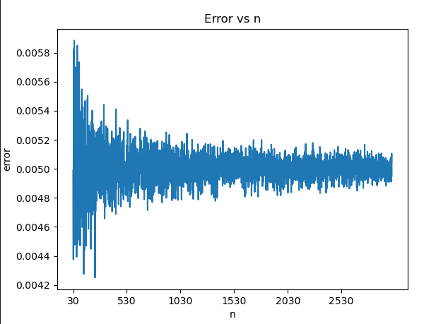

As done in **7a**, the maximum error possible is **δ(b-a) + error due to the composite trapezoidal rule**. The **error δ(b-a)** is independent of **h**. Additionally, the expected error was observed to be **0.005**. This is due to the fact that the random [0,1) function of python has the mean 0.5.

From the graph, it can be seen that **n > 1500, h < (1/1500)** is a reasonable choice for the step size. (This is because after **n>=1500**, the error stabilizes around **0.005** (as shown in the plot)).